FISH 558: Decision Analysis in Natural Resource Management (Fall 2015)
HOMEWORK ASSIGNMENT-3
(Bowhead assessment and decision analysis; Due 23 October 2015)

The purpose of this homework assignment is: a) to use the Sampling-Importance-Resampling (SIR) algorithm to conduct a Bayesian assessment of the Bering-Chukchi-Beaufort Seas stock of bowhead whales (Balaena mysticeus), and b) to use the results of this assessment to form the basis for a decision analysis.

Part A. Bayesian assessment
The model of the population dynamics is:
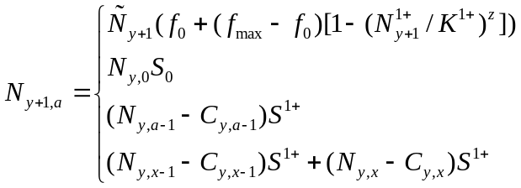 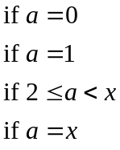 (1)
where 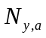 is the number of animals of age a at the start of year y,
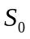 is the survival rate for calves,
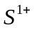 is the survival rate for animals aged 1 and older,
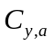 is the catch (in number) of animals of age a during year y,
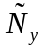 is the number of mature animals at the start of year y (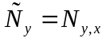),
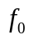 is the fecundity at pre-exploitation equilibrium,
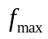 is the fecundity in the limit of zero population size,
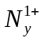 is the total (1+) population size at the start of year y:
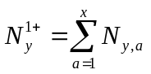 (2)
z is the degree of compensation (2.39),
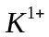 is the pre-exploitation population size (in terms of the 1+ component of the population), and
x is the maximum age (treated as a plus-group and assumed to be equal to 13).
The catch (in number) of animals of age a during year y, , is calculated under the assumption that the catch (Table 1) is removed uniformly from the 1+ component of the population (i.e. calves are not harvested), i.e.:
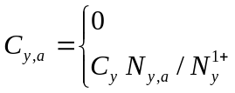 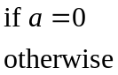 (3)
The likelihood function is based on the assumption that the indices of abundance provide unbiased estimates of 1+ population size, i.e.:
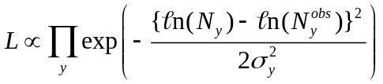 (4)
where 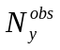 is the estimate of abundance for year y (see Table 2), and
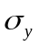 is the observation error standard deviation for year y.
The prior distributions for the estimable parameters of the model are listed in Table 3. Hint: given values for and , it is possible to calculate analytically.
Tasks for Part A.
- Use the SIR algorithm to sample 1,000 parameter vectors from the post-model-pre-data distribution (i.e. the distribution when the only contribution to the likelihood function is whether the population is rendered extinct [0] or not [1]).
- Use the SIR algorithm to sample 200 parameter vectors from the posterior distribution.
- Summarize the results of 1) and 2) by plots of distributions for , , K, and and well as by the posterior for the time-trajectory of 1+ population size from 1848 to 2002 (you can summarize the distribution of 1+ population size for each year by its 5th, median and 95th percentiles).

Notes:
- You need to submit a file that includes the code used to conduct tasks 1), 2) and 3) and all the data files you used. The code should be written so that I can replicate the analyses conducted.
- Design your algorithm to avoid resampling the same parameter vector multiple times.
- Hints:
  - First code the initial condition (year 1848) and the project the model forward without any catches – check the population is totally stable. Then only include the catches.
  - The minimum of the negative of the logarithm of Equation 4 is (about) 2.22 – you should use this information.
  - I wrote a routine which, given the parameters of the model, computes (and returns) the population trajectory and the likelihood function (think carefully about loops in this code, too many can slow the code down a lot). I then wrote other functions which take the same input and return various things (e.g. the negative log-likelihood and the population trajectory).

Part B. Decision Analysis
Tasks for Part B
1. Construct a decision table which could be used to evaluate the consequences of harvests from 2003-2022 of 67, 134 and 201 animals in terms of the probability that the number of mature animals at the start of 2023 exceeds that at the start of 2003 (which captures the desire that this once-highly-depleted population continues to recover). Base your analyses on three states of nature related to the 2003 (1+) population size and calculate the expected probability over all states of nature. Summarize your results in a decision table of the form:

Annual  Catch | 2003 (1+) Population Size |  |  | Expected  Value
Annual  Catch | <7000 | 7000 ≤ P ≤ 8000 | >8000 | Expected  Value
67 | 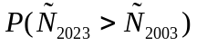
134
201

2. Comment on the choice of performance measure and suggest alternative performance measures and why you consider your performance measures to be more appropriate than the probability that the number of mature animals at the start of 2023 exceeds that at the start of 2003.

Notes:
  - You need to submit the code used for the analyses as well as the decision table.
Table 1
The catch data

Year | Catch | Year | Catch | Year | Catch | Year | Catch | Year | Catch
1848 | 18 | 1879 | 266 | 1910 | 37 | 1941 | 38 | 1972 | 44
1849 | 573 | 1880 | 480 | 1911 | 48 | 1942 | 26 | 1973 | 51
1850 | 2067 | 1881 | 435 | 1912 | 39 | 1943 | 14 | 1974 | 42
1851 | 898 | 1882 | 242 | 1913 | 23 | 1944 | 8 | 1975 | 32
1852 | 2709 | 1883 | 42 | 1914 | 61 | 1945 | 23 | 1976 | 74
1853 | 807 | 1884 | 160 | 1915 | 23 | 1946 | 20 | 1977 | 72
1854 | 166 | 1885 | 377 | 1916 | 23 | 1947 | 21 | 1978 | 15
1855 | 2 | 1886 | 168 | 1917 | 35 | 1948 | 8 | 1979 | 20
1856 | 0 | 1887 | 240 | 1918 | 27 | 1949 | 11 | 1980 | 32
1857 | 78 | 1888 | 160 | 1919 | 33 | 1950 | 23 | 1981 | 26
1858 | 461 | 1889 | 127 | 1920 | 33 | 1951 | 23 | 1982 | 14
1859 | 372 | 1890 | 136 | 1921 | 9 | 1952 | 11 | 1983 | 16
1860 | 221 | 1891 | 284 | 1922 | 39 | 1953 | 41 | 1984 | 16
1861 | 306 | 1892 | 346 | 1923 | 12 | 1954 | 9 | 1985 | 14
1862 | 157 | 1893 | 180 | 1924 | 41 | 1955 | 36 | 1986 | 22
1863 | 303 | 1894 | 234 | 1925 | 53 | 1956 | 11 | 1987 | 29
1864 | 434 | 1895 | 117 | 1926 | 35 | 1957 | 5 | 1988 | 28
1865 | 590 | 1896 | 118 | 1927 | 14 | 1958 | 5 | 1989 | 25
1866 | 554 | 1897 | 130 | 1928 | 30 | 1959 | 2 | 1990 | 41
1867 | 599 | 1898 | 309 | 1929 | 30 | 1960 | 33 | 1991 | 47
1868 | 516 | 1899 | 234 | 1930 | 17 | 1961 | 17 | 1992 | 46
1869 | 382 | 1900 | 148 | 1931 | 32 | 1962 | 20 | 1993 | 51
1870 | 637 | 1901 | 55 | 1932 | 27 | 1963 | 15 | 1994 | 38
1871 | 138 | 1902 | 162 | 1933 | 21 | 1964 | 24 | 1995 | 57
1872 | 200 | 1903 | 116 | 1934 | 21 | 1965 | 14 | 1996 | 45
1873 | 147 | 1904 | 86 | 1935 | 15 | 1966 | 24 | 1997 | 62
1874 | 95 | 1905 | 105 | 1936 | 24 | 1967 | 12 | 1998 | 67
1875 | 200 | 1906 | 69 | 1937 | 53 | 1968 | 27 | 1999 | 67
1876 | 76 | 1907 | 96 | 1938 | 36 | 1969 | 32 | 2000 | 67
1877 | 270 | 1908 | 123 | 1939 | 18 | 1970 | 48 | 2001 | 67
1878 | 80 | 1909 | 61 | 1940 | 20 | 1971 | 25 | 2002 | 67

Table 2
The estimates of abundance for Bering-Chukchi-Beaufort Seas stock of bowhead whales.
Year | 1978 | 1980 | 1981 | 1982 | 1983 | 1985 | 1986 | 1987 | 1988 | 1993
Estimate | 4820 | 3900 | 4389 | 6572 | 6268 | 5132 | 7251 | 5151 | 6609 | 7778
CV | 0.273 | 0.314 | 0.253 | 0.311 | 0.321 | 0.269 | 0.186 | 0.298 | 0.113 | 0.071

Table 3
The prior distributions.
Parameter | Prior
Calf survival, | U[0.8, 1]
Non-calf survival, | U[0.9, 1]
Carrying capacity, K¹⁺ | U[10000, 20000]
Maximum fecundity, | U[0.25, 0.33]

